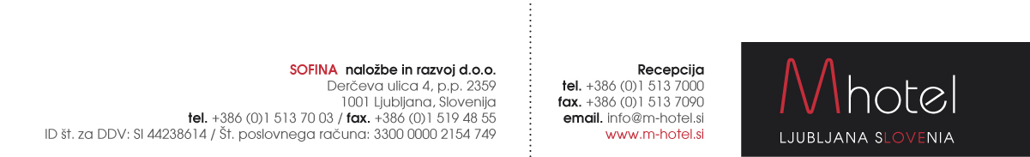

**HOTEL RESERVATION FORM - M HOTEL LJUBLJANA**

**(6.6. – 9.6.2017)**

Reservations to be sent to the following e-mail address: [**anja.novak@m-hotel.si**](mailto:anja.novak@m-hotel.si)

|  |  |
| --- | --- |
| First and last name: |  |
| Room type and number of persons: |  |
| Arrival date: |  |
| Departure date: |  |

**Rates:**

|  |  |
| --- | --- |
| Single room:  Single Superior room  Double / twin room:  Double Superior  Tourist tax: | 70 EUR / night.  85 EUR / night.  86 EUR / night.  100 EUR / night.  1,27 EUR / person / night. |

Payments: Payment to be made directly at the hotel. Reservations are upon request.

**Other facilities:**

**Transportation from/to the airport – one way – up to 5 persons: 30 EUR**

M hotel offers you a transfer service from/to Ljubljana's airport: Our taxi driver will be waitting for you at the arrival gate with M hotel sign and your name on it. Payment: directly to taxi driver or at the hotel.

IN CASE YOU NEED OUR TRANSFER SERVICE PLEASE FILL IN YOUR FLIGHT DETAILS:

ARRIVAL DATE:

ARRIVAL TIME:

FLIGHT NUMBER:

NUMBER OF PERSONS:

**Transportation to the Faculty of the Mechanical Engineering or Cankarjev dom:** **5 EUR per car.** Reservations to be done at the reception. Transportation is possible also from the Faculty to the hotel or other locations.

**Welcome to M hotel!** [www.m-hotel.si](http://www.m-hotel.si)

All the modern hotel rooms are comfort with, free Wi-Fi, air-conditioning, minibar, satellite TV, hairdryer, direct dial phone. Very comfortable mattresses from the latoflex. Parking places. Lunch or dinner every day.

. 